- test case
1.1 issues
Step to find the bugs:
- When you begin to register, you need to fill the necessary information,and then register. You will get a confirm email when you finish the form.when you log in the email try to confirm the register.when you click the link in the email, it does not work.
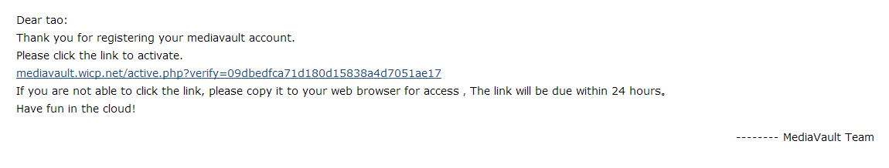
1.2the register test case
Test case | Test scenario
1.register
2.add the email value | Test the formation of the email
3.add the passwords
4.confirm the passwords | Test the difference of the two values
5.confirm email when you finish
6.log in the email
7.click the link in the email | Test the link

